**REVIEW PROCESS**

**PEER REVIEW PROCESS**

The goal of this peer review procedure, which is basically a quality control mechanism where specialists assess submissions, is to guarantee that published science is of a high caliber. Peer reviewers, however, do not decide whether to accept or reject publications. Journal editors or the journal's editorial board are the only ones with the power to make decisions, and they are regarded as key players in the process.

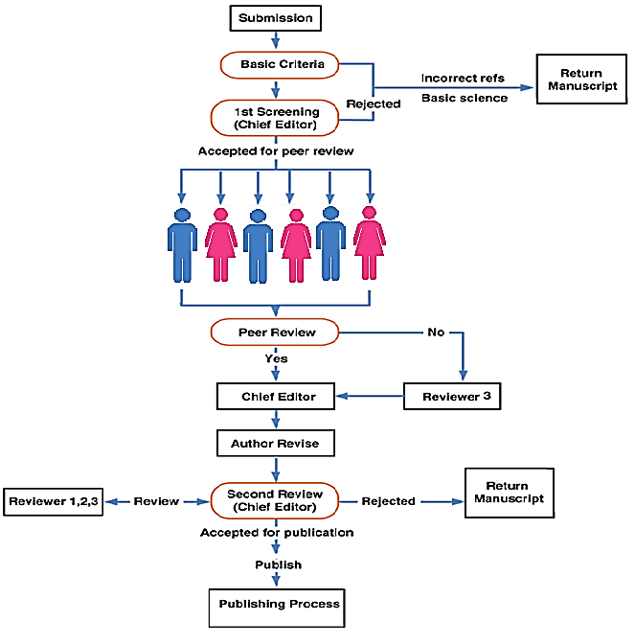

**INITIAL SCREENING (1-20) DAYS**

Every manuscript that is submitted goes through the preliminary review process. Journal editors primarily look for the following at the first screening:

1. Will the manuscript be interesting to the readership and match the Journal's goals and scope?
2. Does the manuscript accurately reflect the standards set by QQRR?
3. Does the manuscript's writing and minimum acceptable quality make it worthwhile to review?
4. Does the paper adhere to the author guidelines provided by the QQRR?

**PEER REVIEW (2-4) MONTHS**

1. Once a manuscript clears the above-mentioned initial screening, it is sent for double-blind peer review in which the names of reviewers and authors are not revealed to each other. A minimum of 2 peer reviewers (up to 4) are chosen for the peer review.
2. Peer reviewers are ideally experts in their field. The peer review is completed once all the reviewers send the journal a detailed report with their comments on the manuscript and their recommendations.

**FINAL DECISION**

The Editorial board of the journal of QQRR considers the feedback provided by the peer reviewers and arrives at a decision for accepting or rejecting the article. After accepting the article and pre-publishing it, the final edition is done.